10.2:

where positive torques are taken counterclockwise, so the net torque is 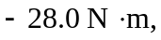with the minus sign indicating a clockwise torque, or a torque into the page.

